Instruction:

Complete all questions in 2:30 hrs

Let’s get started with some helpful Batch scripts:

1. What is Windows Start-up? How can all the start-up programs be viewed?

A startup program is a program or application that runs automatically after the system has booted up. Startup programs are usually services that run in the background.

All the start-up programs can be viewed by following ways:

* Open “Settings.”
* Select the “Apps” option.
* Click on “Startup Apps.



1. Write a batch script to display a simple “Hello Your Name” message during the startup.

**Note: Copy the file to the Startup folder**

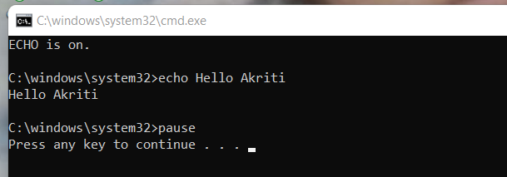

1. Write a batch script to schedule to automatically back up important files and folders to a different location at a scheduled time.

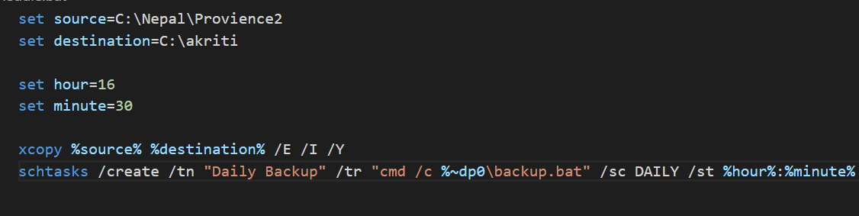

1. Write a Windows batch script that automatically deletes temporary files and clears out the recycle bin to free up space on the hard drive.

1. Write a windows batch script that can be run to diagnose and troubleshoot common network issues.

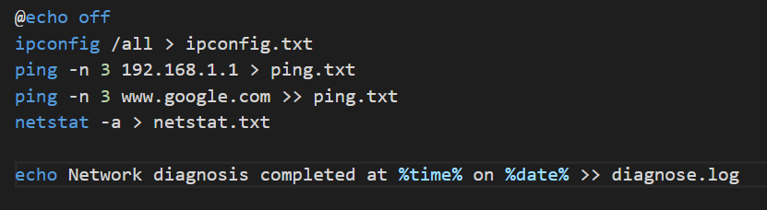

1. Write a batch script that can be scheduled to shut down the computer at a specific time (**using** **WINDOWS TASK SCHEDULER**).

1. Copy the following script Save this and run this in the **Downloads** directory or any directory you want.

*@echo off*

*for %%a in (".\*") do (*

*if "%%~xa" NEQ "" if "%%~dpxa" NEQ "%~dpx0" (*

*if not exist "%%~xa" mkdir "%%~xa" (*

*move "%%a" "%%~dpa%%~xa\"*

*)*

*)*

*)*

What does the above script do? Elaborate on your answer.

Using folders with the same name as the file extension, this Windows batch script arranges the files in the current directory. The script use a for loop to run through each file in the current directory, denoted by the wildcard “. *," and makes use of the variable "%%a" to denote the currently open file. The first if statement examines the file's extension, while the second if statement determines whether the file is now in the current directory. After that, the script checks to see if the current directory already contains a folder with the same name as the file extension using the "if not exist" statement. If the folder is not already there, the script uses the "mkdir" command to create it.